The slider image is the feature image that circulates through images on the main page of the website as seen in figure 1 and 2. Slider images are not constrained to only 2 and as many images can be uploaded to be used as a slider using this tutorial.



Figure 1 &2

A good rule of thumb for multiple slider images is to have the same dimensions for both or multiple slider images and for them to be at least 1600px wide and 200 px in height. The default dimensions of the current slider are: 1600px wide and 543px in height.

Px stands for pixel which is what online images are composed of. The recommendation allows for the slider to look uniform with the width of the layout.

Exceeding the recommended dimensions of the slider may cause the website to load slower and overshadow the layout. For example, if the slider image is too large such as 3000px in width and height it will make the page load much slower, especially for mobile users and will move the ‘About’ section lower onto the page.

The dimensions of an image can be seen by right-clicking on the image in your folder and selecting ‘Properties’ at the bottom of the menu as seen in Figure 3.

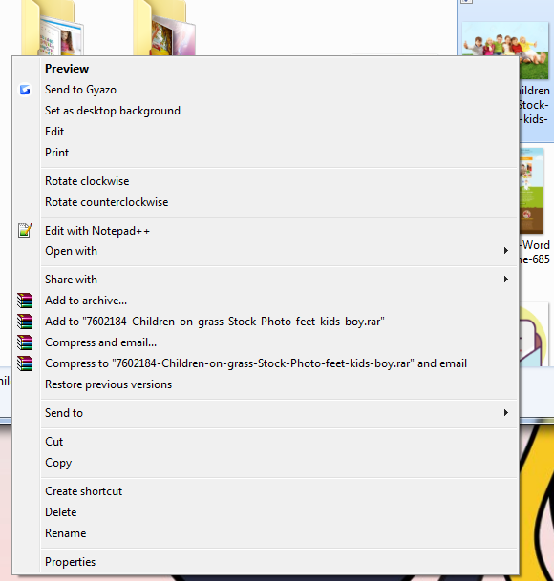

Figure 3

After which, navigating to the ‘Details’ tab will reveal the dimensions of the image as seen in Figure 4.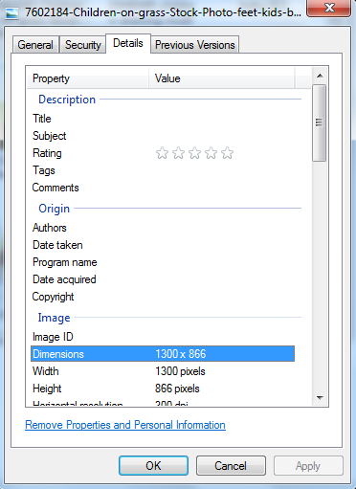

Figure 4

It is possible to crop and resize images to the suggested dimensions by downloading an image manipulation or graphic software such as Adobe Photoshop. Once an image is ready to be displayed as a slider, the user will navigate to the ‘Post’ tab and select ‘New Post’ on the left-sidebar of WordPress as seen in figure 5. 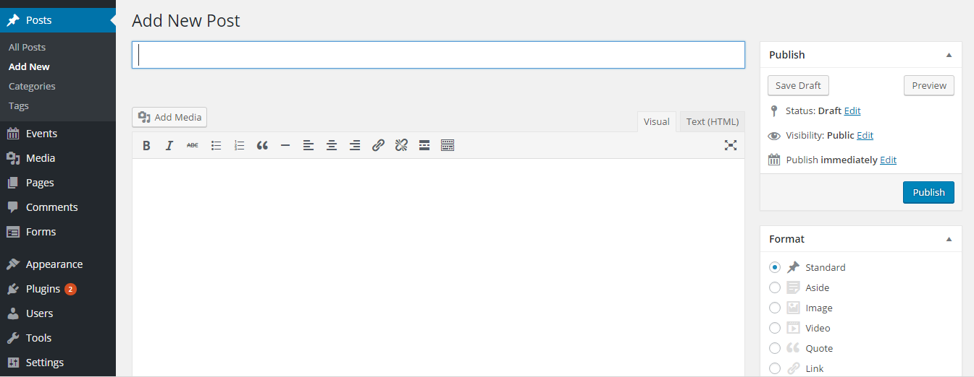

Figure 5

In order for the slider to be uploaded to the website it requires three components a slider title, feature image, and category. A category known as ‘Slider Post’ as seen in Figure 6 has already been created for the admin so it will not be necessary to create another one.

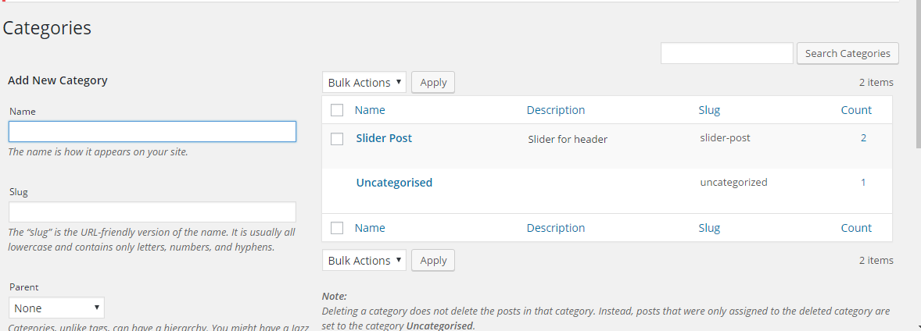

Figure 6

The title as seen in Figure 7, is unimportant as it will not be revealed on the website but should be descriptive of the slider image for better organization.

Figure 7

Once the title has been named and inputted into the field, the admin must scroll and check-mark the ‘Slider Post’ tag as seen in the Categories box on the right-hand bar of the Post page as seen in Figure 8.



Figure 8

After which, it is time to upload the slider image under ‘Featured Image’ as seen in Figure 9, which can be seen two boxes down from the ‘Categories’ box. By clicking ‘set feature image’ a pop-up window will be revealed.



Figure 9

The pop-up window will display two tabs on the top-left corner of the window. The first tab is the ‘Media Library’ which is a compilation of any images previously uploaded while using WordPress for the website as seen in Figure 10.

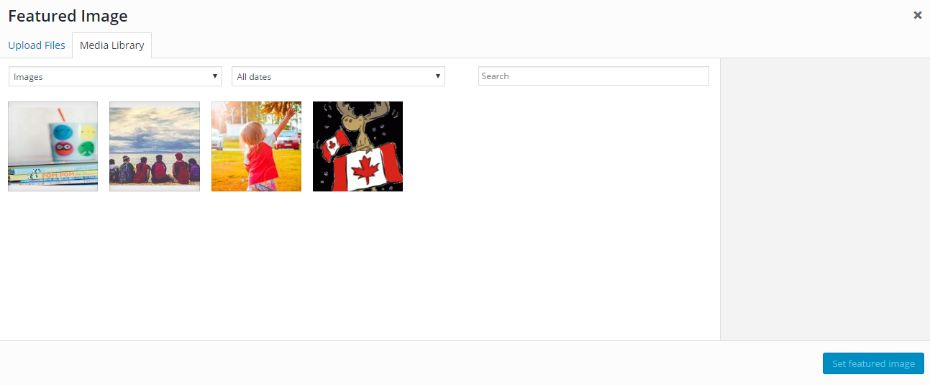

Figure 10

To upload a new image, select the left-most tab ‘Upload Files’. This will open another new pop-up window as seen in Figure 11. Navigate to the directory of the slider image by navigating through the folders. Once the image has been found, select the image and click on ‘Open’. 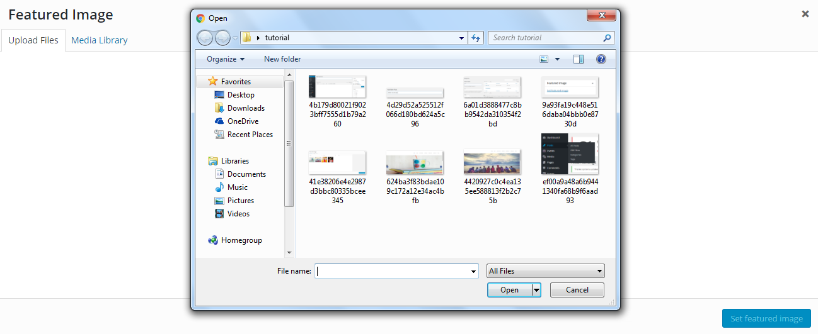

After which, click on the ‘Set Feature Image’ which is the blue button in the bottom right corner of the window also seen in Figure 11.

After the image has been set, a preview of the image will be revealed in the ‘Featured Image’ box as seen in Figure 12.



Figure 12

The last step is to publish the slider post by pressing the ‘Publish’ button which will be the first box on the right-hand side of the ‘Post’ screen as seen in Figure 13.

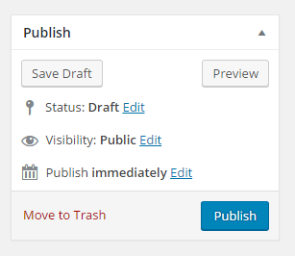

Figure 13

Any time the admin wishes to upload another slider, perform the above steps with a new title name for each slider image. If the admin decides to later want to remove a slider image, click on the ‘Post’ tab again and it will reveal a compilation of all posts created. Hovering the mouse over the title of the slider they wish to remove will reveal a ‘delete’ text in red and clicking on it will delete the respective slider as seen in figure 14.

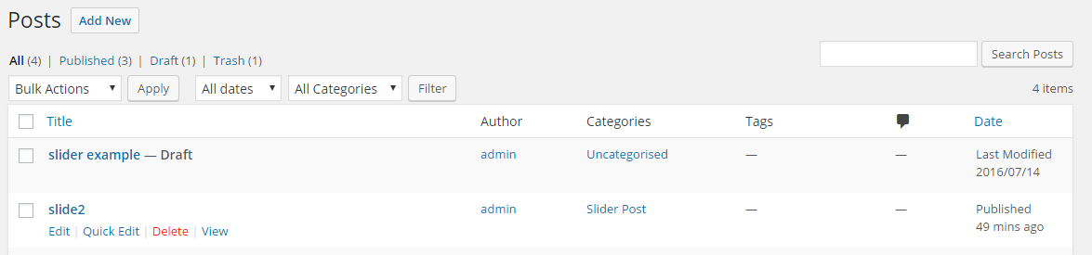

Figure 14